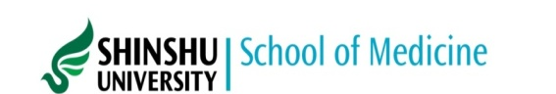
Elective program
APPLICATION FORM

First name  Middle name(s)  Family name |  |  |  | Attach Photo
Gender  □ Male  □ Female | Date of birth  dd/mm/yyyy | Age | Nationality | Attach Photo
Postal address  E-mail  Telephone (*Please include country code) |  |  | For emergency contact  Name of the person  Email  Telephone  Fax
Full name of your home medical institution

Address of the institution

Total years of your medical studies required for the Degree of Medical Doctor: ( ) years
Semester you will be in at the time of participation: ( ) th semester
Expected year of graduation: (yyyy)
Have you passed skills examination for a clinical rotation?: □Yes □Not yet
Experience of clinical practices in hospitals:
□ None
□ Yes
( ) weeks at the Department of in (country)
( ) weeks at the Department of in (country)

Languages
Native language:
English proficiency:
Japanese proficiency:
Period of participation
From to
dd/mm/yyyy dd/mm/yyyy Duration of training ( ) weeks
Please list 3 departments/fields you wish to train at.

□ Research:
1. 2. 3.
□ Clinical:
1. 2. 3.
Will you earn any credits for the training on this elective program?
□ Yes. Subject title: Amount of credits:
□ No.
If you are going to receive any scholarship to participate in this program, please provide its details.
Name of scholarship Amount
If you have any previous entry or stay in Japan, please state the length in total.
For ( ) weeks/months/years
Date of application

Signature of applicant

